* I will work on a 3D space game   
    
  I will reproduce the Metro station Andel in Prague

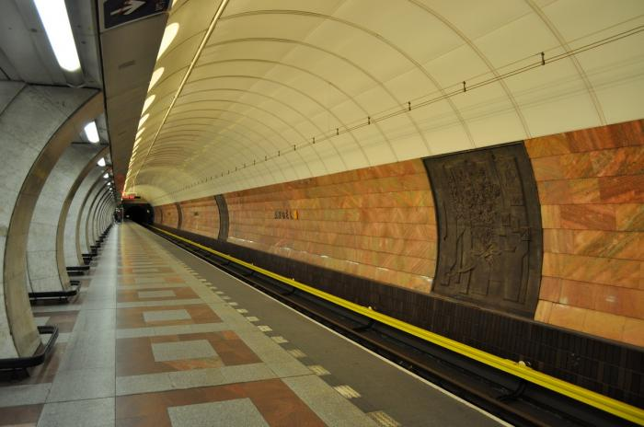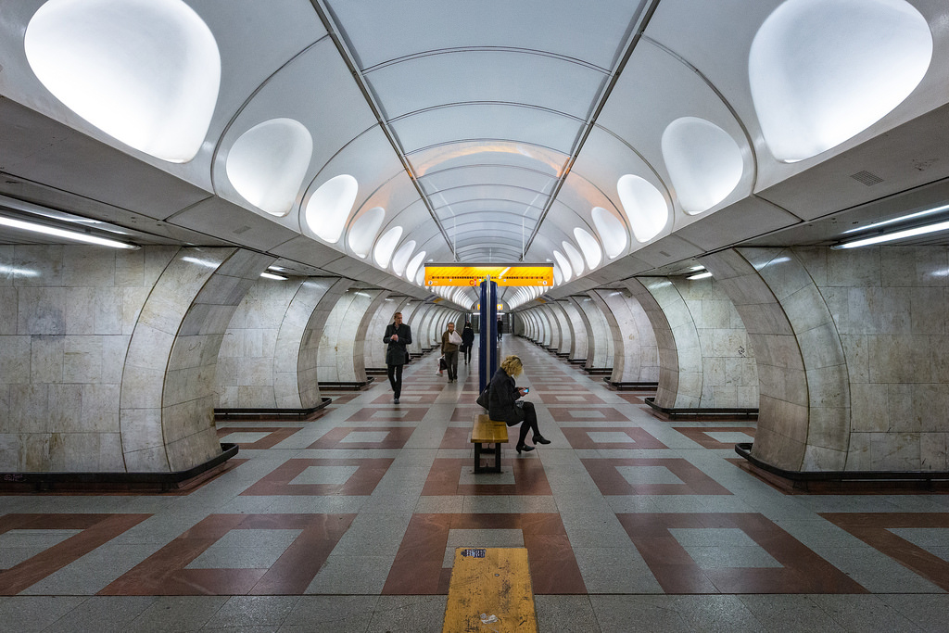

inspiration:

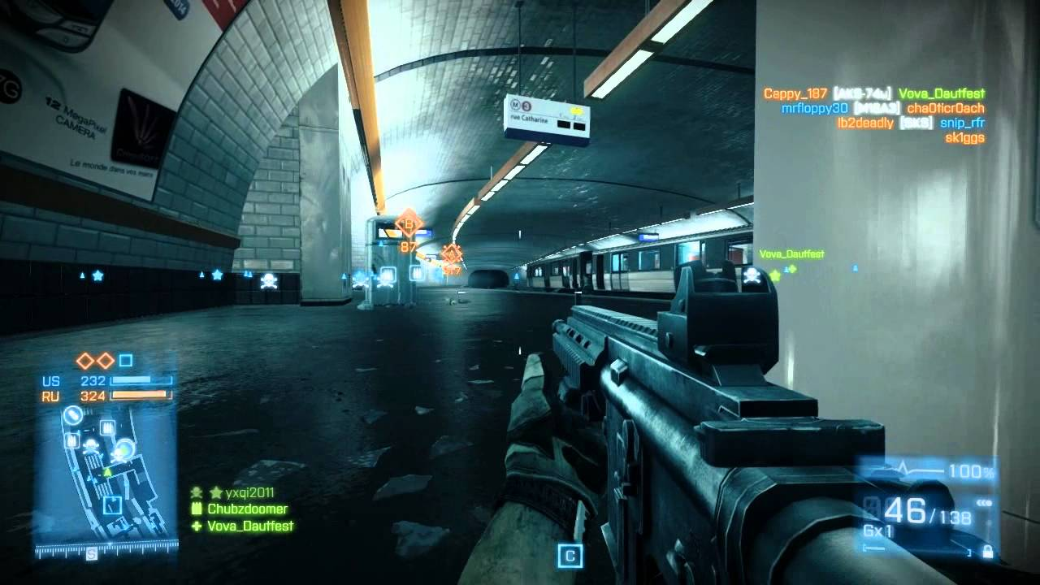

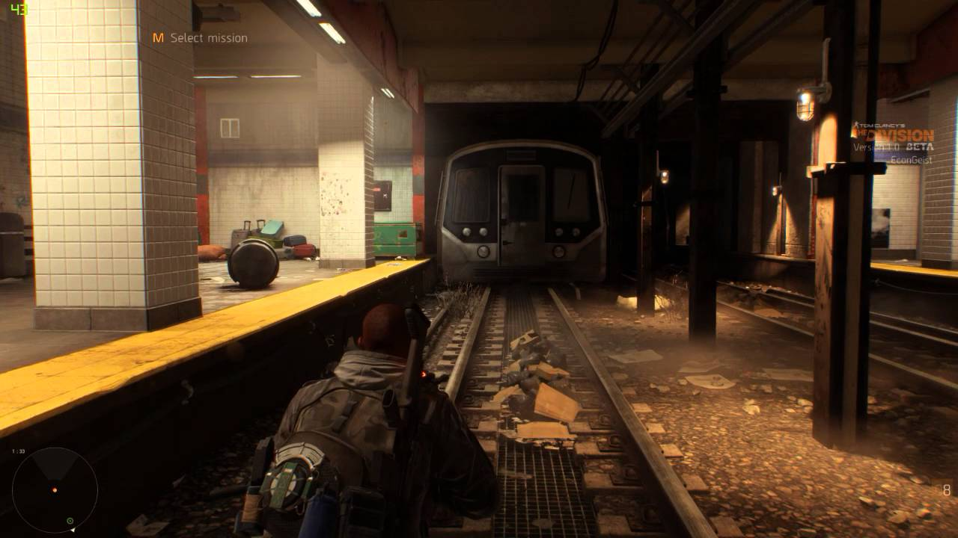

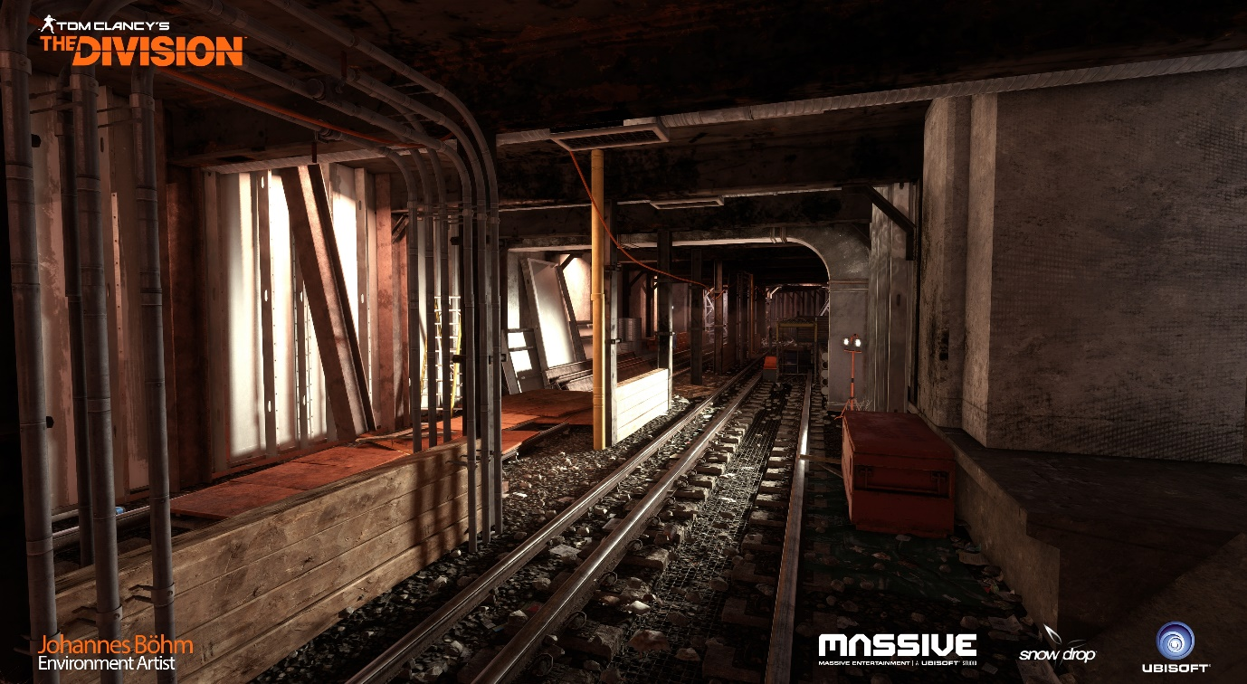

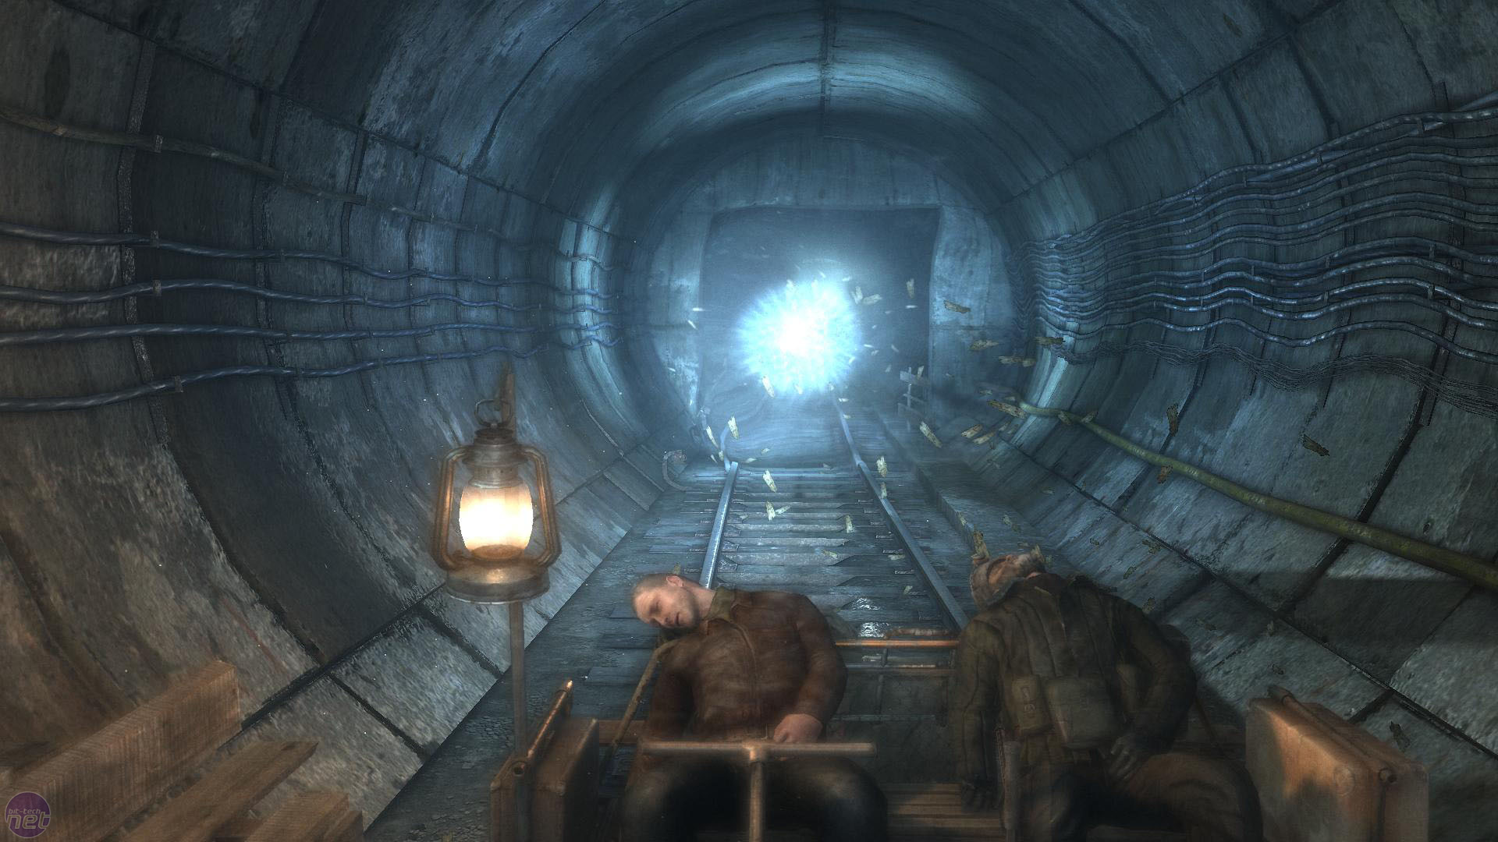

* 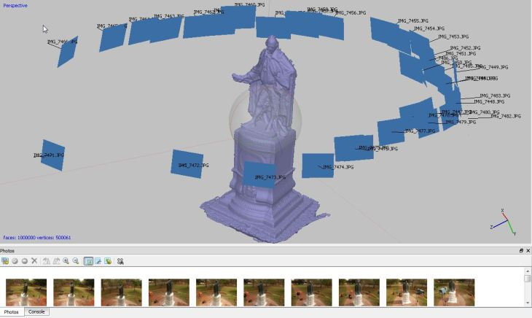Will try to do a photogrammetry of the place. If too complicated, I will try to reproduce them using Substance Designer.
* I will try to create a dark place, with dynamic lights and reflections all over the scene. The scene will be played in first person (very simple character which can walk, run, jump)
* You will be able to walk around the whole station.
* Some objects (with a blocking wall) will be blocking the characters from entering the Escalators or getting too far in the tunnels
* I will make the scene in 3DS max and will design every single object, panels, signs, etc.
* Whole metro place
* Trains
* Add details
* Put in Unity
* Work on the lights
* Find the mistakes